HF Receiver Principles
Noise and Dynamic Range
Presented by Jamie Hall WB4YDL
April 26, 2012

Noise
- The most pervasive source of noise is thermal noise.
  - Every conductor generates noise
  - Thermal noise is white noise, meaning it does not vary with frequency
  - Noise density corresponds to bandwidth (noise power or spectral density)
  - Amount of thermal noise in 2.5 kHz is -140 dBm
  - For good communications, an SSB signal should be ~ 10 dB higher than the noise (SNR = 10 dB) for a signal power of -130 dBm.
  - Antenna noise is the noise the antenna produces, not the physical temperature of the antenna.
    - Example: point dish antenna at sun and white noise will increase
- In a rural setting, noise sources are less man-made and more atmospheric and galactic.
- Below 18 MHz, rather poor receiver sensitivity is acceptable because of very high external noise
  - Explains why simple receivers of 1920's were relatively successful
  - Possible to use rather inefficient receive antennas on lower frequencies
- At VHF (and above) frequencies, antenna (external) noise levels are much lower and low-noise receivers are required for good performance.
Dynamic Range
- In general, dynamic range is the ratio (or difference in dB) between the weakest signal a system can handle and the strongest signal that same system can handle simultaneously.
  - Also defined as the span of signal strengths a circuit can handle without generating false signals that can interfere with communications.
- A linear stage e.g. a mixer, tracks input signal dB for dB - first-order response.
  - No device is perfectly linear - tubes, transistors, microprocessors
  - Two or more signals applied to it generate sum and difference frequencies - IMD products.
- Second-order IMD products change 2 dB for every decibel of input signal change. Appear at simple addition and subtraction of input signal frequencies.
  - Example: amplifier subjected to 6 and 8 MHz signals will produce second-order products at 2 MHz and 14 MHz.
- Third-order IMD products change 3 dB for every decibel of input signal change. Appear at frequencies of sums and differences of twice the input frequency plus or minus the frequency of another.
  - Example: amplifier subjected to signals at 14.02 MHz (f₁) and 14.04 MHz (f₂) produces 3rd order IMD products at 14.00 (2f₁ - f₂), 14.06 (2f₂ - f₁), 42.08 (2f₁ + f₂), and 42.10 (2f₂ + f₁) MHz.
  - The subtractive products 14.00 MHz and 14.06 MHz are close to the desired signal and can cause significant interference.
- Because IMD products increase faster than the desired output as the input level rises, eventually this results in equal desired signal and IMD levels. This is a hypothetical point - a mathematical extrapolation - 3rd order intercept point (IP3).
  - Real devices are incapable of reaching this point
  - Every device overloads and is no longer linear. Called compression.
  - Point at which first-order response deviates from linearity by 1 dB - 1 dB compression point.
  - Saturation - input signal increase no longer increases output signal.
- Blocking dynamic range is the difference in dB between minimum discernible signal (MDS) and an single off-channel signal that causes 1 dB of compression in the receiver.
  - Different than IMD dynamic range which requires two signals (more dynamic !).
- We may have two interfering signals that are not within our operating bandwidth so we don't hear either by themselves.
  - If signals are 2 kHz and 4 kHz from our desired signal, they will combine in a non-linear circuit to produce a product exactly on our desired frequency !
- Manufacturers of communications equipment have traditionally posted the IMD DR measured at 20 kHz - now called wide-spaced DR.
  - In our crowded bands, this is no longer a useful number.
  - Narrow-spaced DR is measured at a much more realistic 2 kHz.
    - Will always be worse than wide-spaced DR
    - > 80 dB is desirable
      - First achieved by Ten-Tec Omni VI+ and Elecraft K2
      - Now able to achieve > 95 dB - Elecraft K3 and Yaesu FTdx-5000D, TT Orion II and FLEX 5000A.

A Way to Measure Receiver Sensitivity

Using a simple, single frequency (7040 kHz) crystal oscillator with an output of 1µV, a receiver's signal-to-noise ratio (SNR) and minimum discernible signal (MDS) can easily be calculated. This is useful to evaluate a new receiver, check the condition of a old receiver, or check a receiver after exposure to lightning or other traumatic event. The Elecraft XG1 can easily be pocket carried and is an ideal tool to evaluate used gear at a flea market or hamfest.
1 µV corresponds to -107 dBm. Remember, P = I x E, but we are measuring voltages. So change I to E/R and we have P = E²/R. Also remember that power is being referenced to 1 mW or .001 watt. 1 micro-volt is .000001 volt or 10⁻⁶ volt. Squaring this gives 10⁻¹² volts and then dividing by 50 gives 2 x 10⁻¹⁴ watts. Calculating for dBm = 10 x log (2 x 10⁻¹⁴/.001) = -107 dBm.
After turning the AGC off and setting the RF gain to max and setting the filter bandwidth to 500 Hz (the standard for this measurement), we'll connect the XG1 crystal oscillator to the antenna connector. Set the receiver to 7040 kHz. We'll take voltage measurements from the speaker output. You can also use an external speaker connector. Remember, audio voltages are AC (or RMS).
Turn the oscillator on for 1 microvolt output and measure the voltage across the speaker. This is the signal + noise ([S+N]) value. My Elecraft K1 measured 550 mV. Next turn off the oscillator and take another voltage measurement. This is just the noise (N) measurement. My K1 measured 36 mV. Dividing the two values gives the [S+N]/N = 550 / 36 = 15.28.
We can now calculate minimum discernible signal (MDS). Now, because we are comparing power but measuring RMS voltage, we end up with a small change in the equation. dBm = 10 log (V²/V²) . R (resistance) cancels out. Another logarithm rule states that log xⁿ = n log x. So the equation becomes dBm = 20 log (V/V). Well V/V is what we just measured as the [S+N]/N. So we have 20 log (15.28) which equals 20 x 1.184 = 23.68 or about 24 dBm. This is the SNR in dBm.
MDS is thus -107 - 24 dBm = - 131 dBm. This is a reasonable number given that a typical noise floor is -135 dBm. So the K1 should be able to 'hear' signals a few dB above the noise floor.

S-Meter Calibration

The XG1 crystal oscillator also has a 50 µV output setting which, by definition, is S9 on a standard S-meter.
Making sure the AGC is ON, set the oscillator to 50 µV. Use the menus of the radio (or manual adjustment) to set the meter to read S9. 50 µV corresponds to -73 dBm.

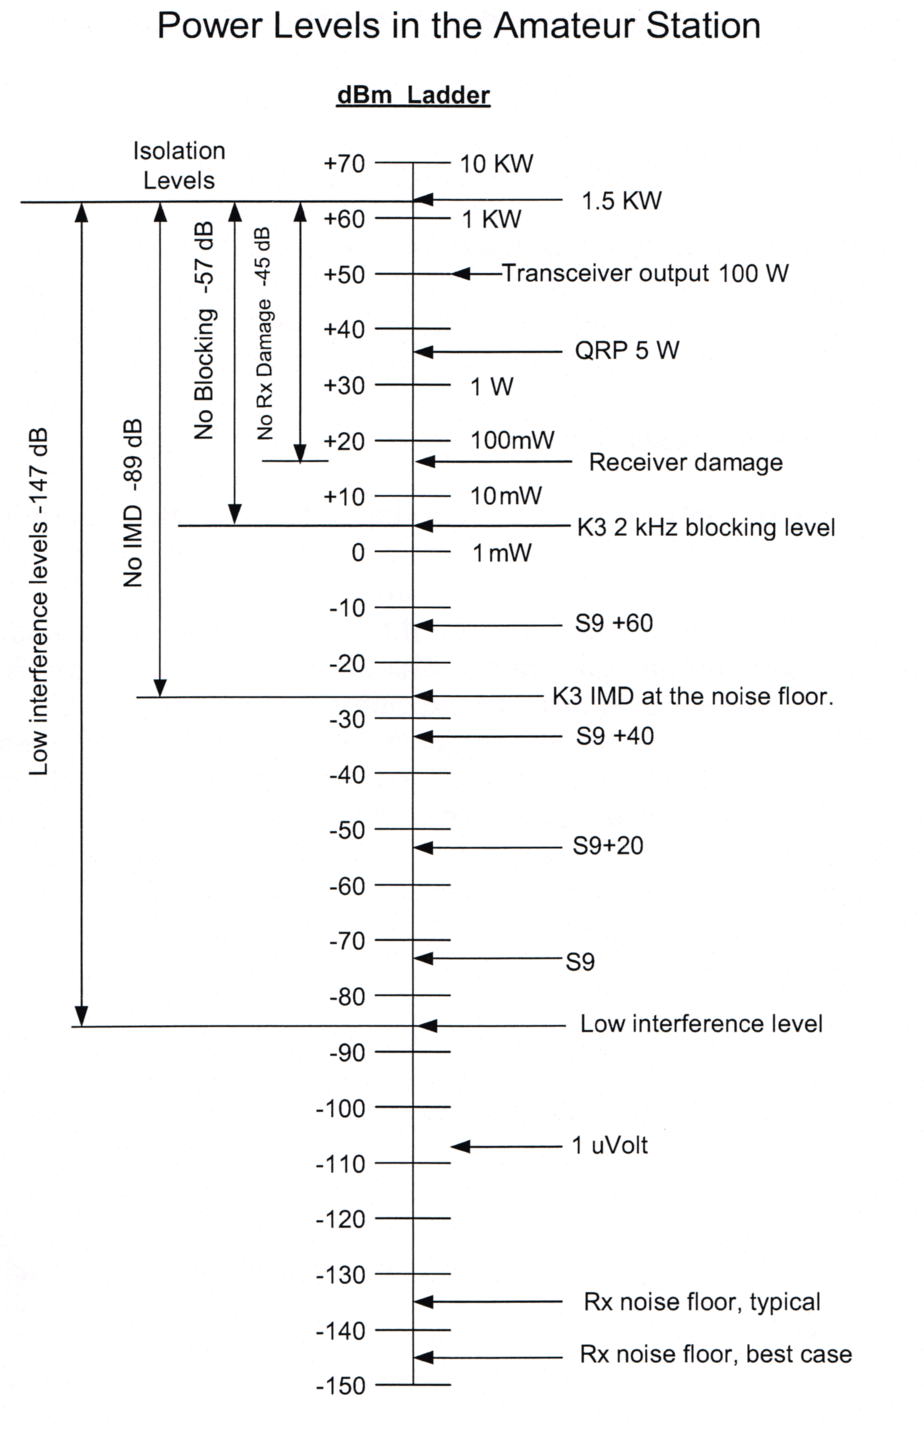
= 50 µV = -73 dBm
= -107 dBm

References

- The ARRL Handbook for Radio Communications, 2012, 89th edition
  - Noise, chapter 5.8
  - Putting Mixers, Modulators, and Demodulators to Work, chapter 10.4
  - Superhet Receiver Design Details, chapter 12.4
- Orr, William I., Radio Handbook, 23rd edition, chapter 6, Communication Receiver Fundamentals
- Sherwood Engineering, Inc., http://www.sherweng.com/table.html , Receiver Test Data
- Åsbrink, Leif, Blocking Dynamic Range in Receivers, QEX Mar/Apr edition, 2006, http://www.sm5bsz.com/dynrange/qex/bdr.pdf .
- Frisk, James R., W1DTY (SK), Receiver noise figure sensitivity and dynamic range - what the numbers mean, Ham Radio Magazine, October 1975, http://www.r-390a.net/Receiver-Specifications-Explaned.pdf .
- A Few Words About Intermodulation Dynamic Range and Roofing Filters, http://www.qth.com/inrad/roofing-filters.pdf .
- Cutsogeorge, George W2VJN, Managing Interstation Interference, 2nd edition revised, chapter 1
- Rohde & Schwarz, application note 1MA98, dB or not dB? Everything you ever wanted to know about decibels but were afraid to ask, http://cas.web.cern.ch/cas/Denmark-2010/Caspers/Decibels%20from%20Rohde%20Schwarz%20Darmstadt%20CAS%202010.pdf
- Stark, Peter A, Communications 101 Textbook, http://www.users.cloud9.net/~stark/commbook.htm
  - Chapter 9, The Superheterodyne - http://www.users.cloud9.net/~stark/ct9.pdf
  - Chapter 10, Receiver Fine Points - http://www.users.cloud9.net/~stark/ct10.pdf
- Extra Class Exam Pool, Ham Test Online, section E4D, Receiver performance characteristics, http://www.hamradiolicenseexam.com/question_pools/extra_2008/E4D.htm
- Watson, Robert E., The Communications Edge, Receiver Dynamic Range, Part 1, http://www.dbmengineering.com/products/tech-library/docs/WJ_classics/vol14_n1.pdf
- Watson, Robert E., The Communications Edge, Receiver Dynamic Edge, Part 2, http://www.triquint.com/products/tech-library/docs/WJ_classics/vol14_n2.pdf
- Ferguson, Carl W4UOA, Receiver Metrics: Theory and Practice, TARC Presentation PPT, http://www.w4uoa.net/TARCPresentationv14.ppt
- Sherwood, Rob NCØB, Roofing Filters, Transmitted IMD, and Receiver Performance, BARC2008.PPT, http://www.sherweng.com/documents/Barc2008.ppt
- Raczek, Tadeusz SP7HT, The DX Prowess of HF Receivers, QEX Sept/Oct edition, 2002, http://www.arrl.org/files/file/Technology/tis/info/pdf/020910qex036.pdf

